**Designing For Virtual Environments**

**Group Project**



**VR Shoe Store**

Eoin Gallinagh – 17430126

Liam Aspell – 17300046

Ahmed Alagtal – 19408182

Syed Muhammad Khurshid Abbas – 19490746

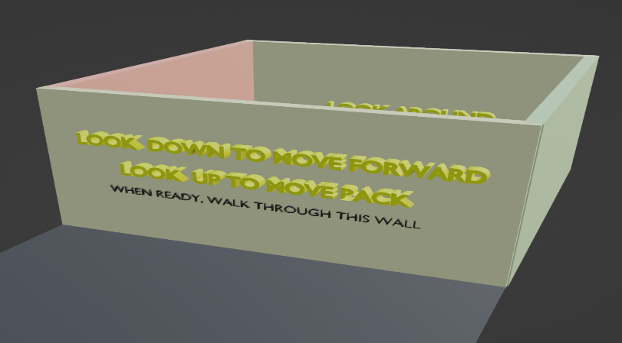Student Name – Student Number

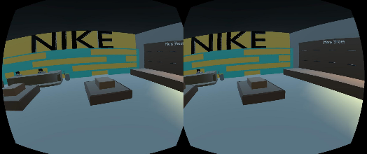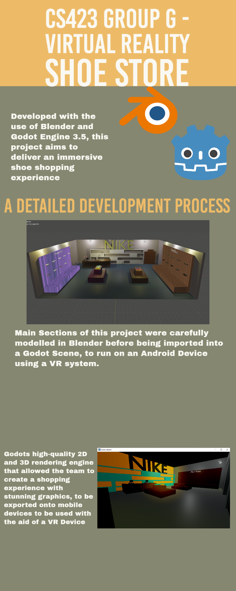**Infographic**

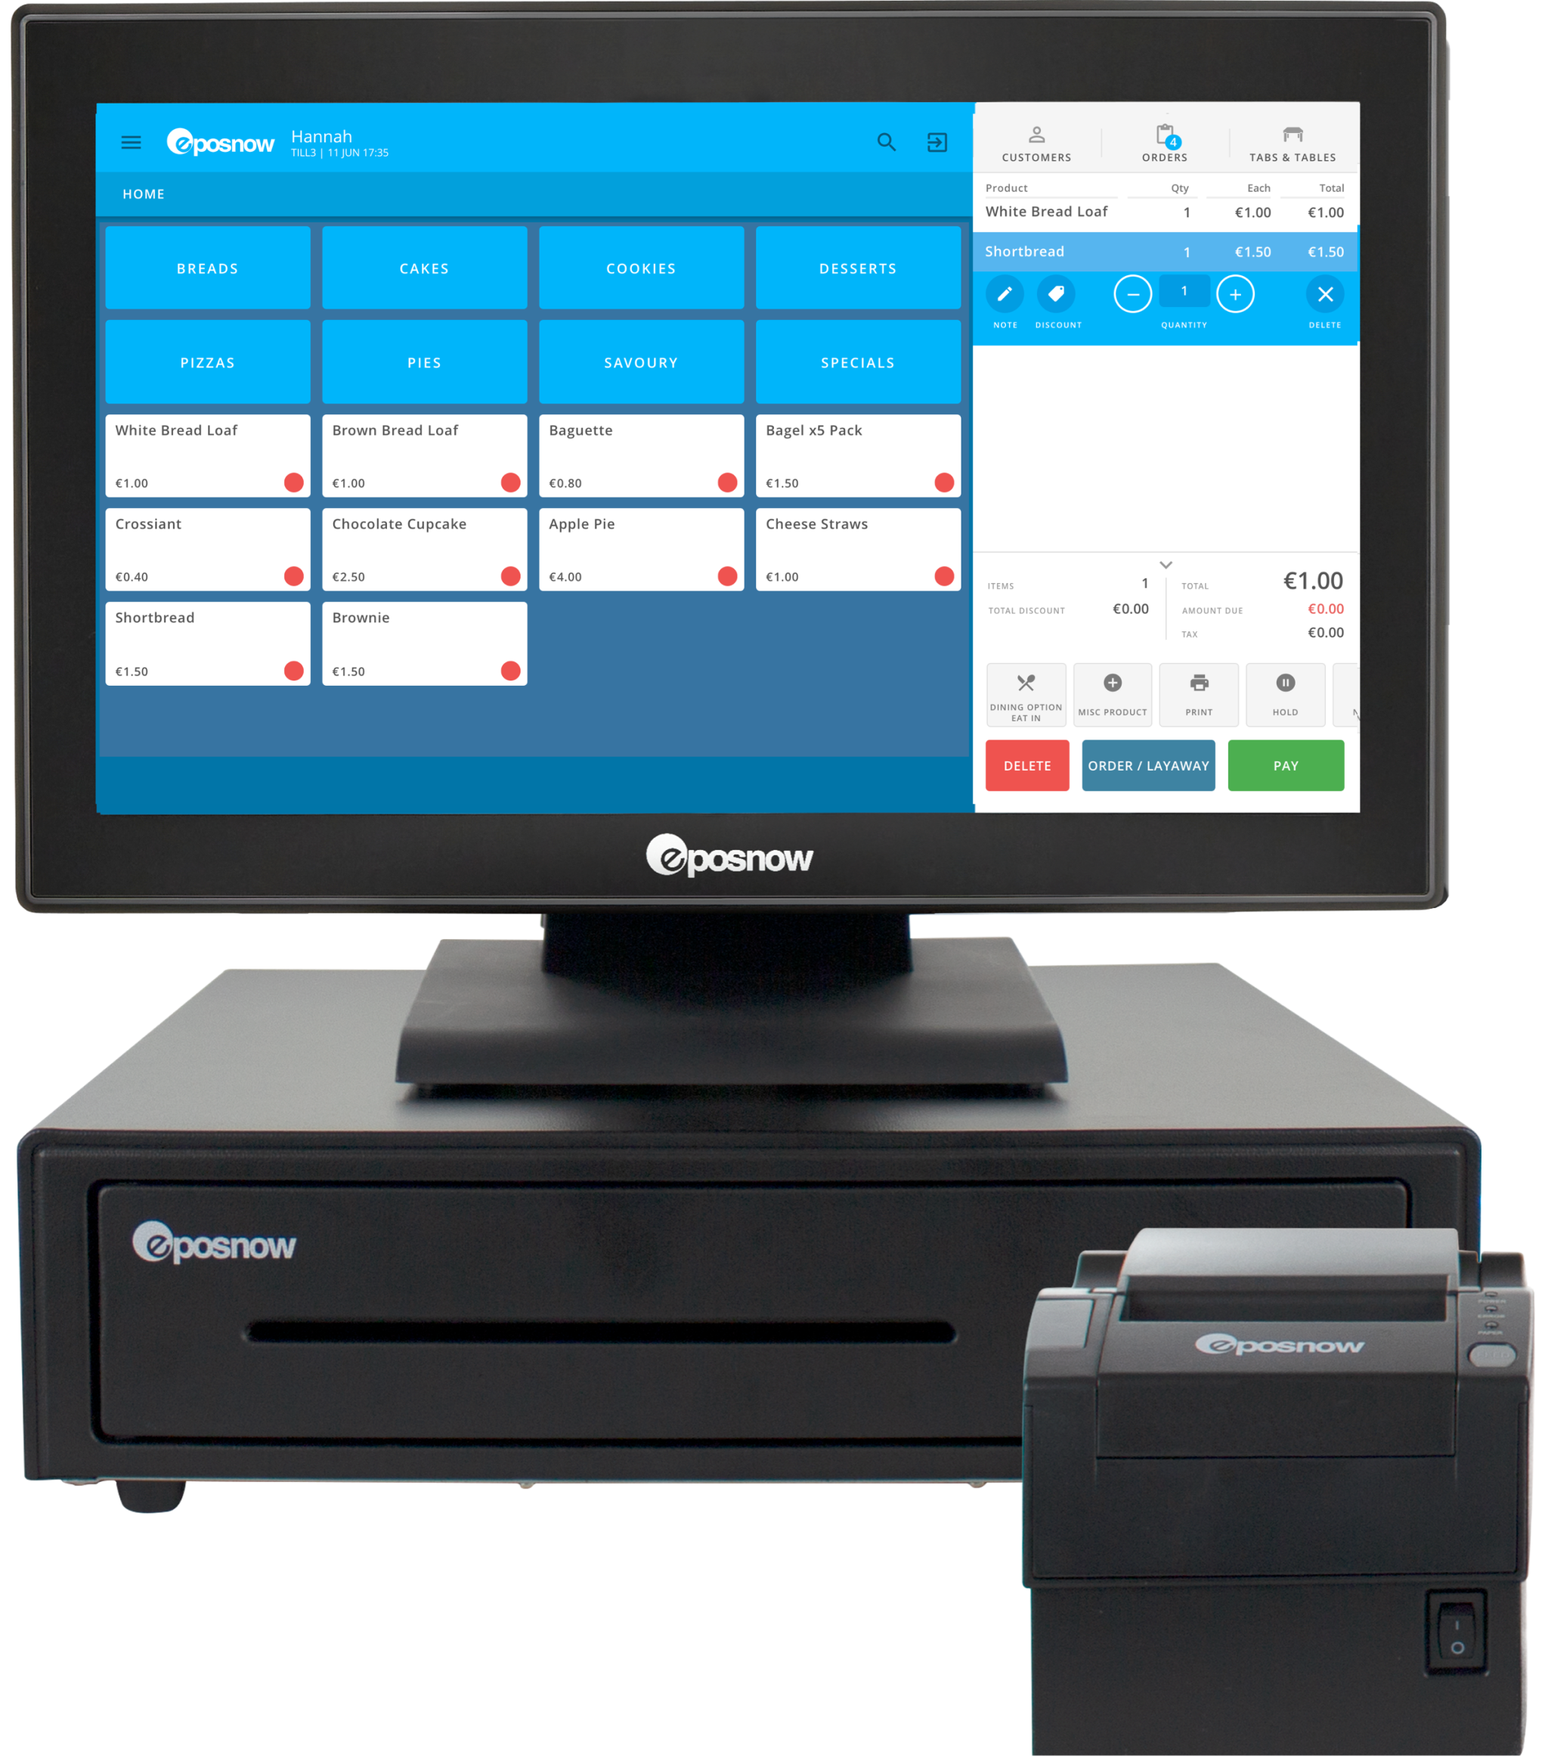Every store requires a minimum of one cash register to function. Cash register designs were inspired by online images, such as the one referenced. Subsequently, the design was replicated and modified slightly to represent both an open and closed till for added versatility.

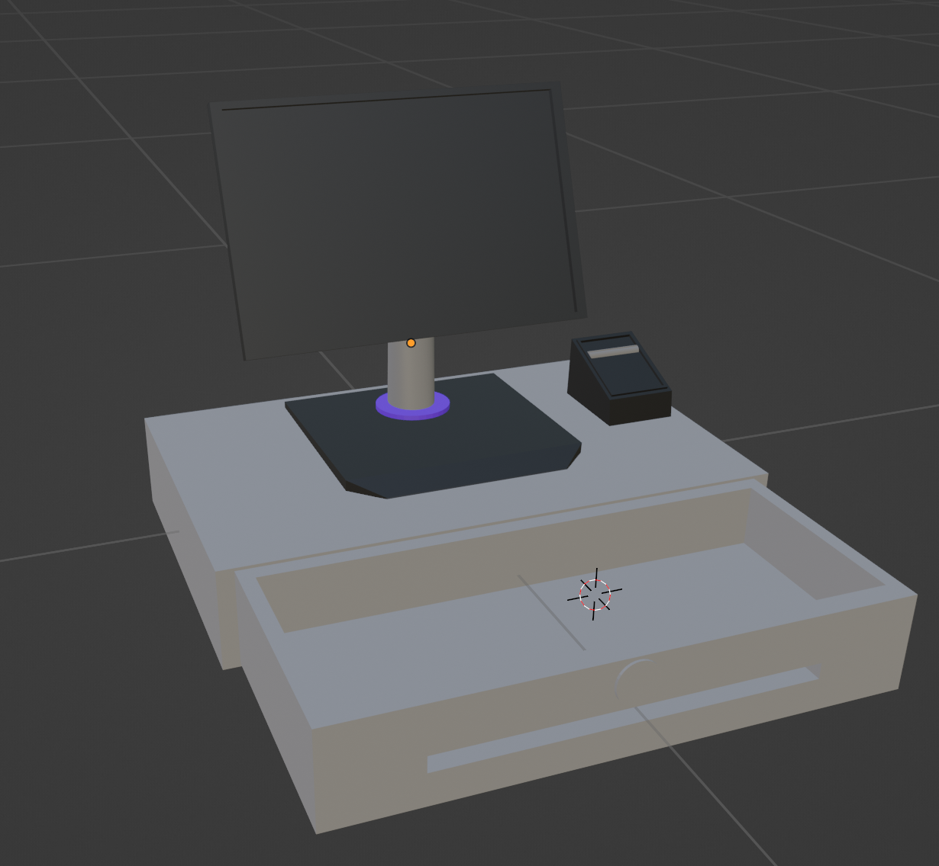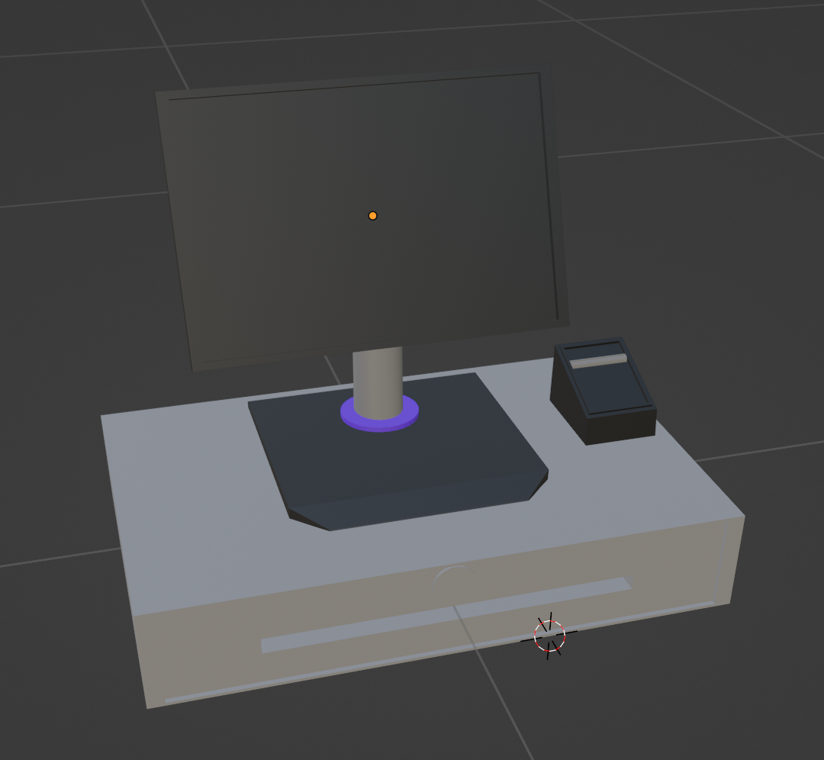

These cash registers were positioned next to a conventionally designed counter and waste bin.

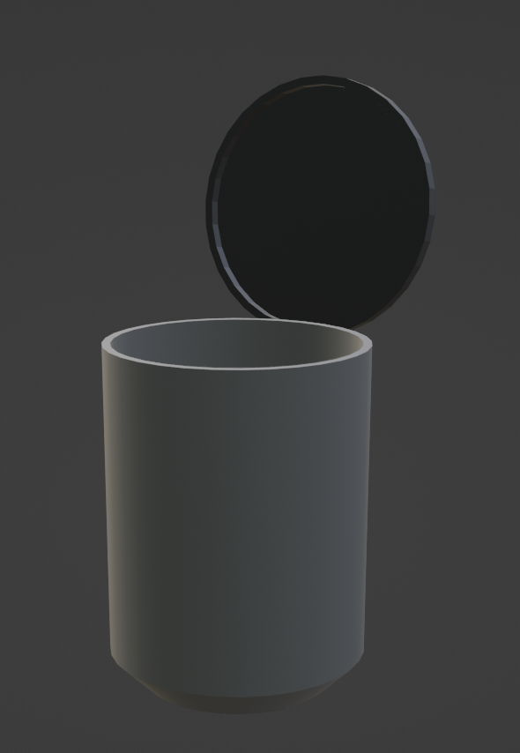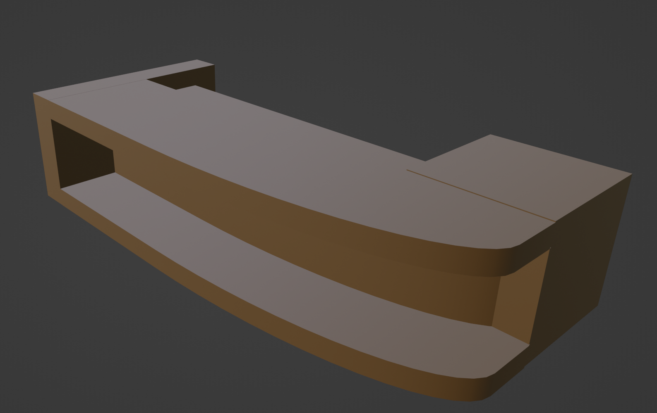

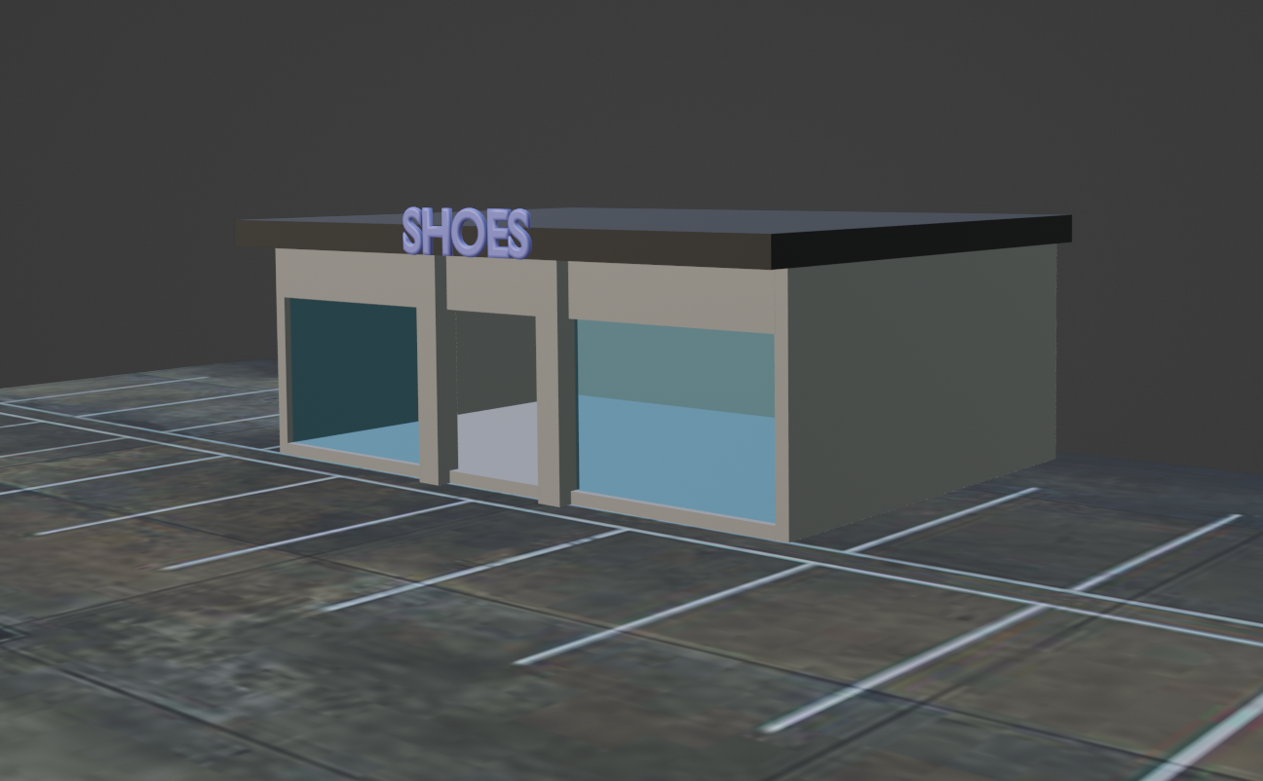

The exterior of the premises featured a minimalist design, aiming to keep the focus on the interior shopping experience. Although, starting in a spacious parking lot at a distance from the store, users would have the opportunity to familiarise themselves with the controls and navigation, ensuring a smooth and effortless traversal of the scene upon reaching the store.

The primary purpose of the main menu is to provide players with an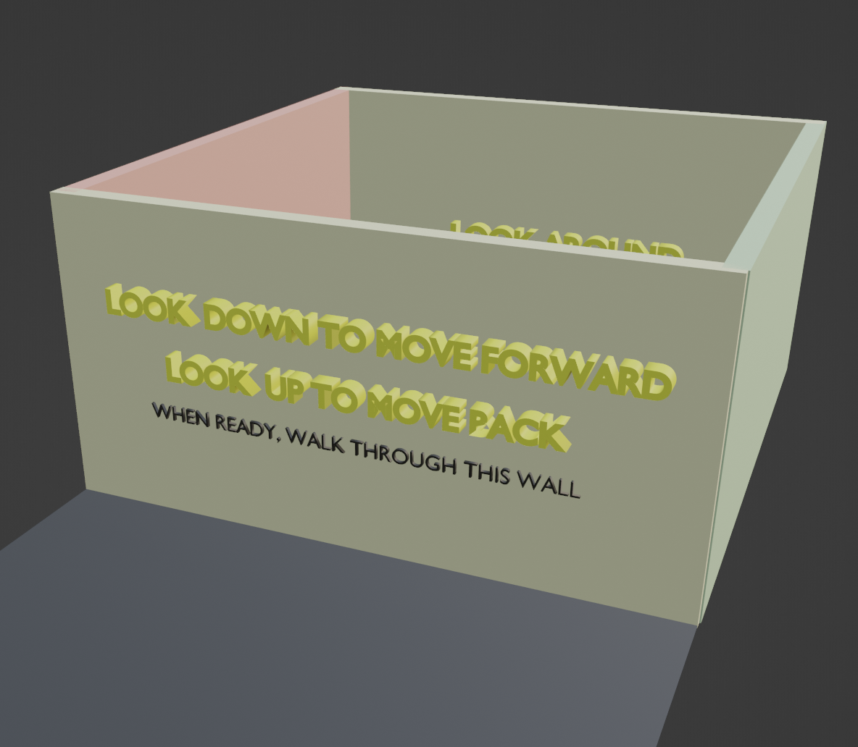 opportunity to familiarise themselves with the controls of their character's movement. The walls in the menu function as instructional aids, demonstrating how to move around. Once the player is comfortable with the controls, they can choose to exit the game or start playing by walking through the wall of their choice. This functionality is achieved through the implementation of areas and collision detection for both the walls and the player.

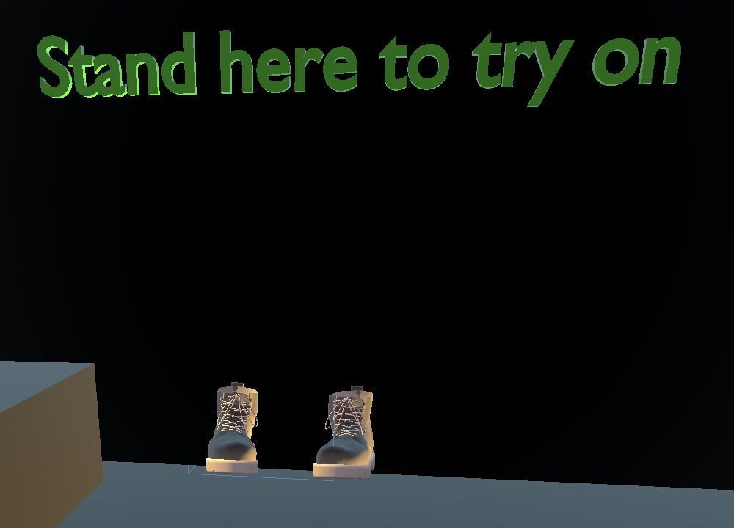

A similar technique is also implemented within the main game, where the user has the ability to “Try on” a pair of shoes. By incorporating collision detection with area entered again, the players movement speed is increased twofold to demonstrate the benefits of wearing the new shoes.

Ahmed Section

We started off discussing as a group what idea we wanted to do and how could we achieve the idea we wanted once we decided on a shoe shop in VR we split the work and everyone had tasks to complete. My responsibilities were as follows:

I was responsible for designing and modelling various types of shoes and slippers for our chosen shoe shop project. I designed shoes for men and women as well as slippers for men and women .I made them in different sizes and colours as not everyone has the same shoe size. Then I use mirror modifies to get the second pair of each shoe or slippers I made. I designed them using blender and worked on the rendering aspect for them too. I also designed shoe boxes as it is a feature that a shoe store entails. Once I completed these tasks, I worked on making a small extra feature to have which was a fruit basket to include on the counter as a complimentary item for customers.

As for Godot I worked on lighting and I adjusted different features in lighting for example the energy power and I was doing trial and error to see what gives the scene a perfect light design.

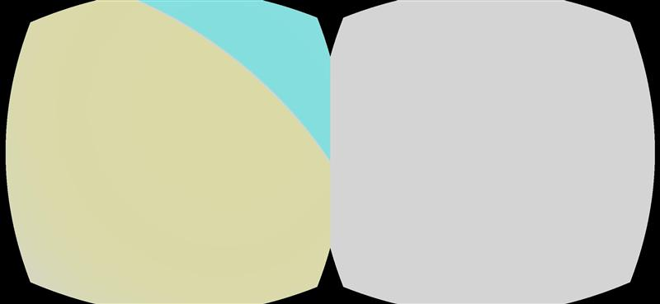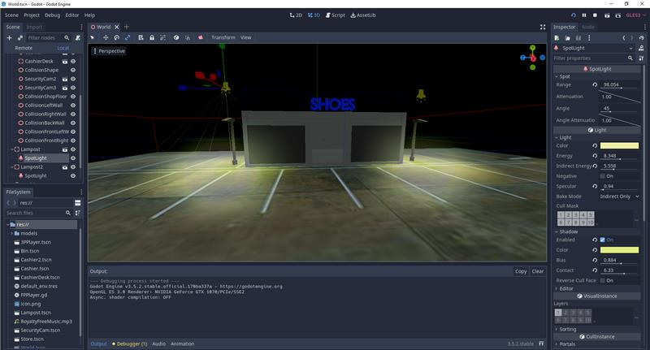Lighting was a tricky aspect of the project to get right. Initially the main light source was a directional light above the store, which was intended to act as a sun. There was also an environment variable node added to further control lighting in the scene. This included adding the lighting to the lampposts in the scene. The team tried many different combinations of realistic lighting elements to go into the scene. However, a major issue was encountered using this method when it came time to export the environment into an APK file to run on a mobile device. The initial export of the APK file when ran was found to be too bright, meaning that nothing in the scene was visible. After doing some research on this, it was found that exporting a Godot scene into an android device may cause issues with world environment variables, as not all devices support the same graphics features, so the lighting effects may not display as intended. This is a particularly difficult issue to debug, as there is no complete way of knowing if some adjustments may cause issues at the end of the export process, when it is time to view the world on the mobile device. For that reason, some of the settings had to be refined and scaled back to ensure a playable game.

**Some extra models to create detail.**

To combine the tasks of practicing modelling in blender to ‘warm up’ for the project, as well as creating detail in the shop scene, a selection of background items was modelled from scratch in blender. Two of these items were the lampposts that are present near the building, and the CCTV cameras which are hanging on the walls of the shopfloor. Models such as these help to create realism to boost levels of immersion.

**Designing the Shop’s Shoe Display Areas.**

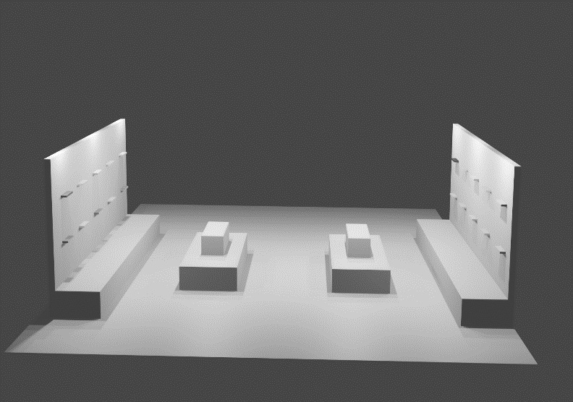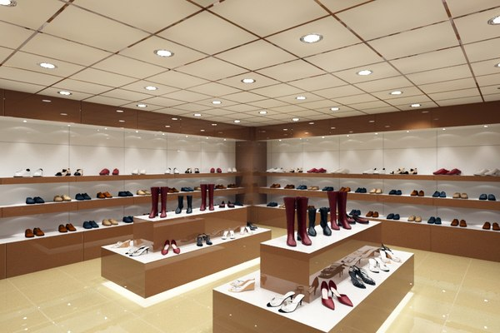The design of the shop was inspired largely by shop designs found online. One such inspiration is contained in the figure below. A scene was developed containing a shoe display wall and a display island. The approach is to have a section both for women and men’s shoes, so the symmetry seen in the model figure below will be split men and women’s sections symmetrically. The wall display units have small shoe holders typically seen in many shoe stores.

**Extra Feature – Shop Music.**

The addition of shop music into the VR environment helps to set the tone within the scene, which enhances the users overall experience interacting with the environment. The music in this scene enhances immersion by stimulating the sense of hearing, which is an important feature of virtual environments. Royalty free music was sourced and placed in the environment using an AudioStreamPlayer node. Overall, music can significantly impact the atmosphere and experience of the shop environment, creating a more engaging and memorable experience for visitors.

Dara Section

Syed Section

Working on the interior of the shop was joyful, while working on the project as a group we realized that there should be a decorative section behind the counter. I went onto designing the section behind the counter and the NIKE logo in blender.

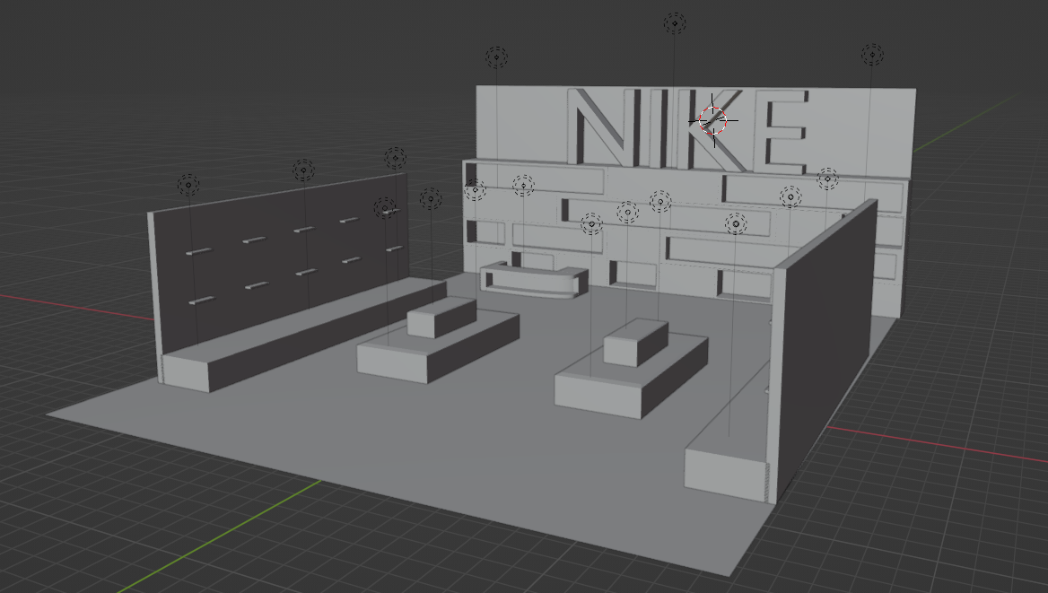

Once that was put together with other sections developed by other students, it gave an appealing look. The lighting was placed above the section, when rendered, it enhanced the overall look. The main purpose to add that section is to give the players a sight of a logo and an easy navigating towards the counter.

It was essential to have different types of shoes for men and women in the shop so along with other students I designed and modified existing models to add to the shop.

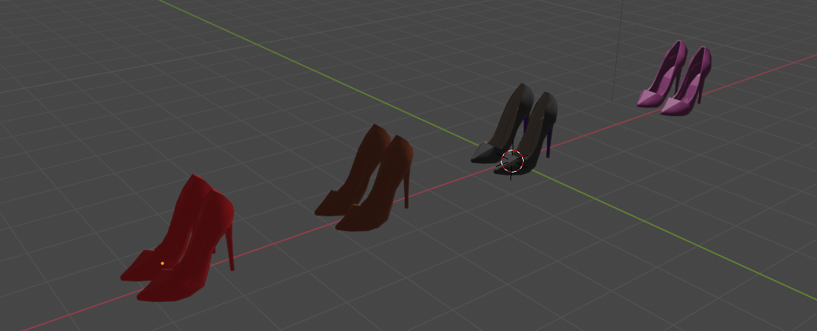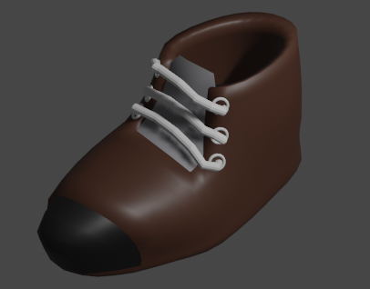

The section outside the shop had a parking lot. We had a discussion in the group to add few cars to give players a feeling of going from the car parking lot to the shop. With a view of cars present in the parking lot it can give a realistic feeling. Following are the models taken from CGTraders.

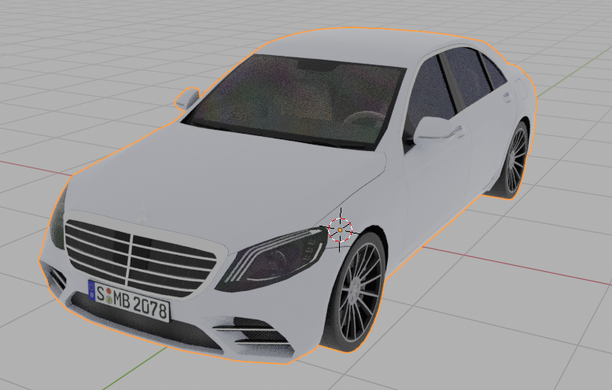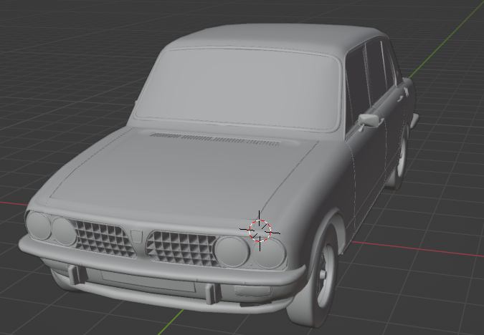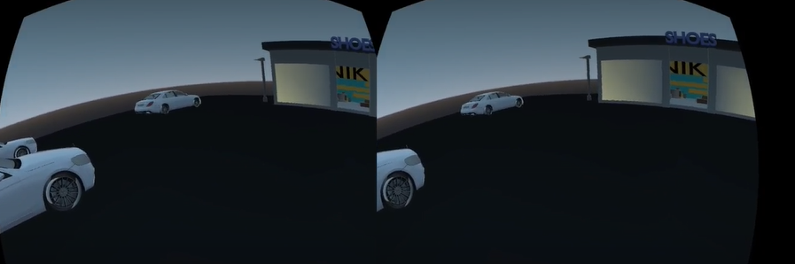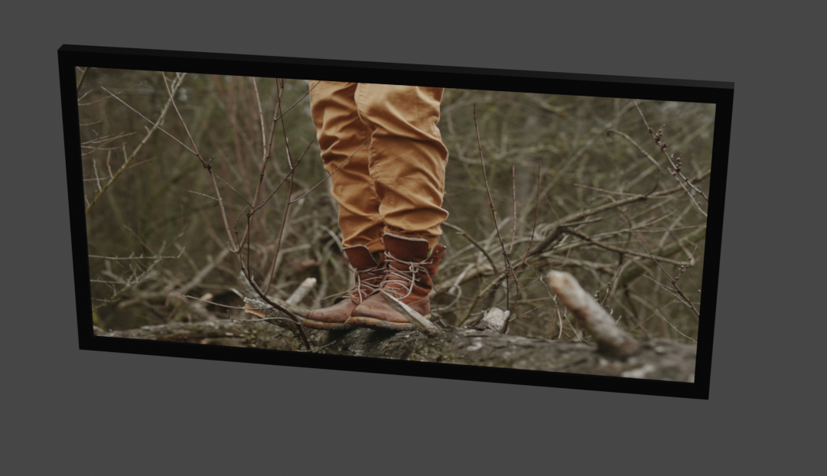

A tv is added in the left corner of the right wall of the shop for AD purpose. One issue was that when viewing it in blender file the animation is displayed on the tv however in godot it’s not functional as a white screen appears. The intention was to allow players to see an add viewing an animation of a boot which would give them a better experience of roaming around the shop.